Fleet Management Operations in the Ops Center
1. Add Fuel Type
- Navigate to Fleet Management
  - Log in to the ops center.
  - From the dashboard, select Fleet Management from the navigation menu.
- Select the Fuel Type Tab
  - In the Fleet Management section, locate and select the Fuel Type tab.
- Add Fuel Type
  - Click on the Add Fuel Type button.
  - Fill in the following details:
    - Fuel Type*: Enter the type of fuel (e.g., Petrol, Diesel).
    - Icon*: Upload an icon representing the fuel type.
    - Status*: Select Active or In-Active from the dropdown menu.
  - Click Submit to save the fuel type.
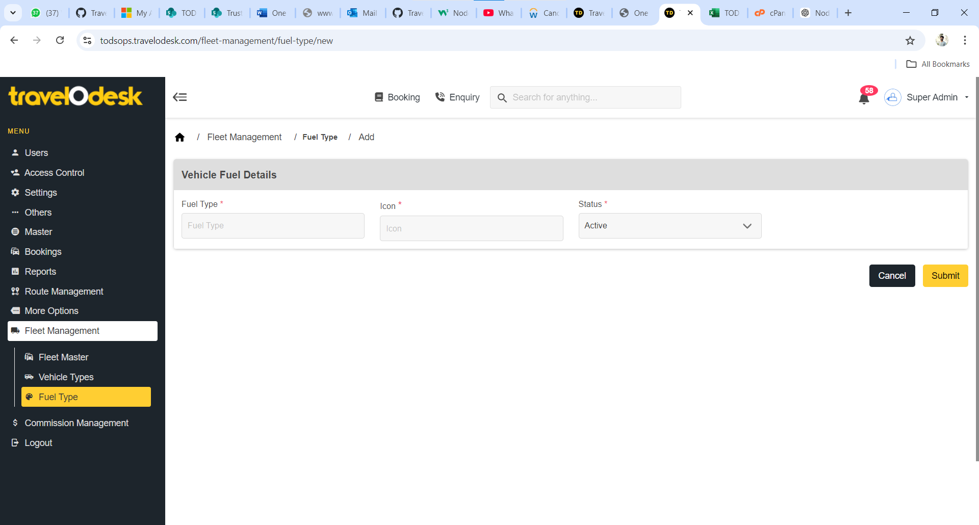

2. Add Vehicle Type
- Select the Vehicle Type Tab
  - In the Fleet Management section, navigate to the Vehicle Type tab.
- Add Vehicle Type
  - Click on the Add Vehicle Type button.
  - Fill in the following details:
    - Vehicle Type*: Enter the name of the vehicle type (e.g., Sedan, SUV).
    - Description*: Provide a brief description of the vehicle type.
    - List Order*: Define the display order for this vehicle type in lists.
    - Status*: Choose Active or In-Active.
    - Vehicle Type Image*: Upload an image for the vehicle type. Ensure the image meets these requirements:
      - Maximum size: 5 MB
      - Recommended dimensions: 640 x 360
  - Click Submit to save the vehicle type.
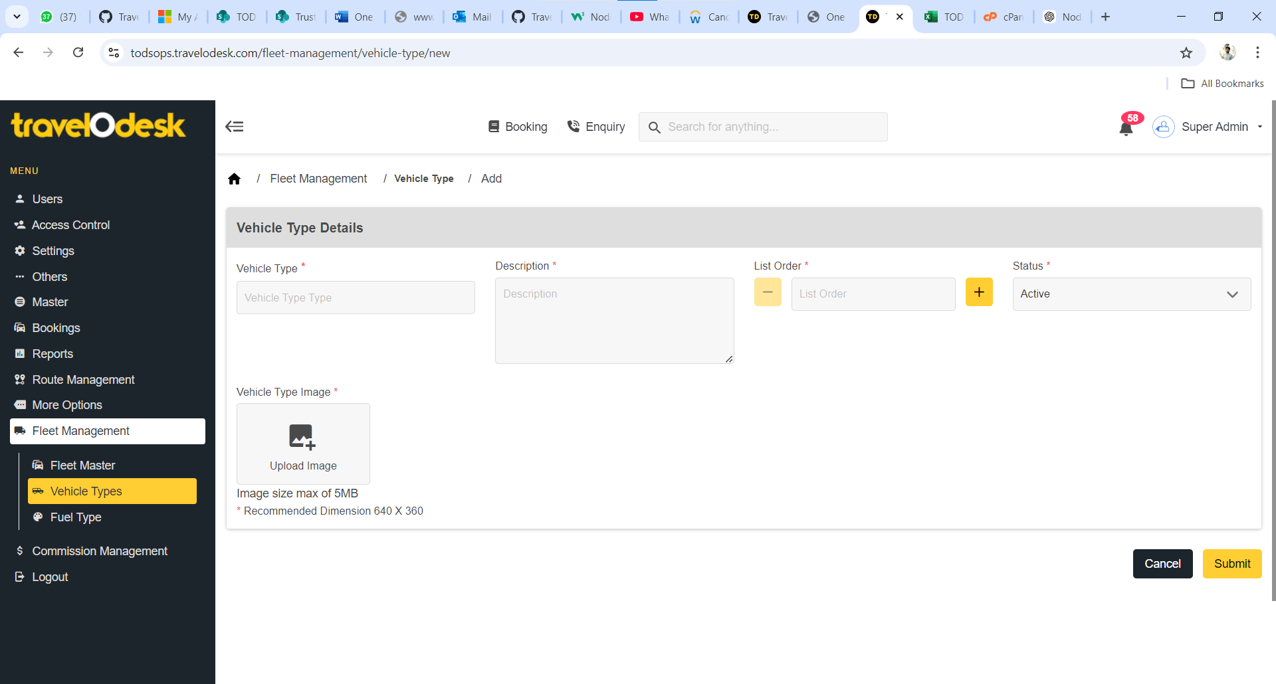

3. Add Fleet
- Select the Fleet Master Tab
  - In the Fleet Management section, navigate to the Fleet Master tab.
- Add a New Fleet
  - Click on the Add Fleet button.
  - Fill in the following details:
    - Vehicle Details:
      - Class Category*: Select the appropriate class category from the dropdown menu:
        - Standard
        - People Carrier
        - Premium
        - Large People Carrier
        - Hatchback
        - Minibus
        - Super Luxury
        - Premium Minibus
        - Standard Bus
        - Luxury Minibus
        - Deluxe Bus
      - Company Name*: Enter the name of the company managing the fleet.
      - Model Name*: Specify the model name of the vehicle.
      - Description: Provide a brief description of the vehicle.
      - Offer Type: Choose an offer type from the dropdown menu:
        - Best Offer
        - Economic
        - Popular
      - Fuel*: Select the type of fuel from the available options:
        - Petrol
        - Diesel
        - CNG
        - Electric
        - LPG
        - Hybrid
        - Petrol + CNG
      - Number of Passengers*: Enter the maximum number of passengers the vehicle can accommodate.
      - Number of Bags*: Specify the number of bags the vehicle can carry.
      - Price Per KM: Define the cost per kilometer for this vehicle.
      - Default*: Select Yes or No to set this fleet as the default.
      - Status*: Choose Active or In-Active.
    - Vehicle Images:
      - Cover Image*: Upload the main image for the fleet. Ensure the image meets these requirements:
        - Maximum size: 5 MB
        - Recommended dimensions: 290 x 160
      - Additional Vehicle Images: Upload up to 5 additional images for the fleet. Ensure each image meets these requirements:
        - Maximum size: 5 MB
        - Recommended dimensions: 290 x 160
  - Click Submit to save the fleet details.
